Risks, Issues and Action Items Using Project Notes

In Unanet Version 9.2 significant enhancements have been made to Project Notes functionality. These enhancements have been made in particular to support improved project management and collaboration through better handling of Risks, Action Items and Issues. This document reviews the new features and provides sample data that may be helpful. A description of risk management best practices is beyond the scope of this document. Helpful guidance on this subject can be found in the Capability Maturity Model Integrated Guide. A link to this is included at the end of this document.

Notes Statuses can now be defined:

Admin >> Setup >> Notes Statuses.

Here you can see a number of valid statuses have been defined by an Administrator to represent the typical lifecycle of Risks, Action Items or Issues. This is completely configurable to your needs.

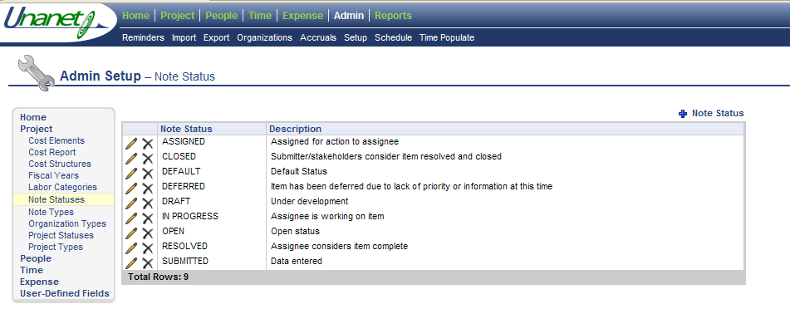

Note Types can be defined as before:

Admin >> Setup >> Project Note Types. Here we can see that various types have been defined by an Administrator.

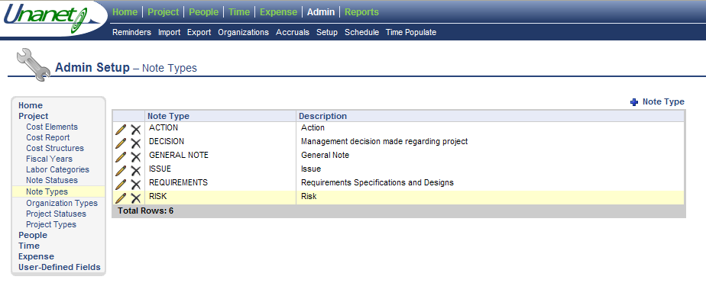

A powerful new feature of Project Notes is the addition of User Defined Fields (UDF).

Admin >> Setup >> User Defined Fields >> Project Note
As with other User Defined Fields we can specify a field type, with values for pick lists if that is the type, whether it is required with default values, enabled/disabled etc. Sample UDFs and values are shown in the images below:

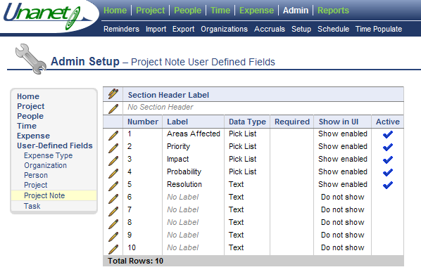

The first example Notes UDF defined is Areas Affected. This could be used to capture the business area, or product functionality, or some other category which the Note, and specifically an Issue or Risk might apply.

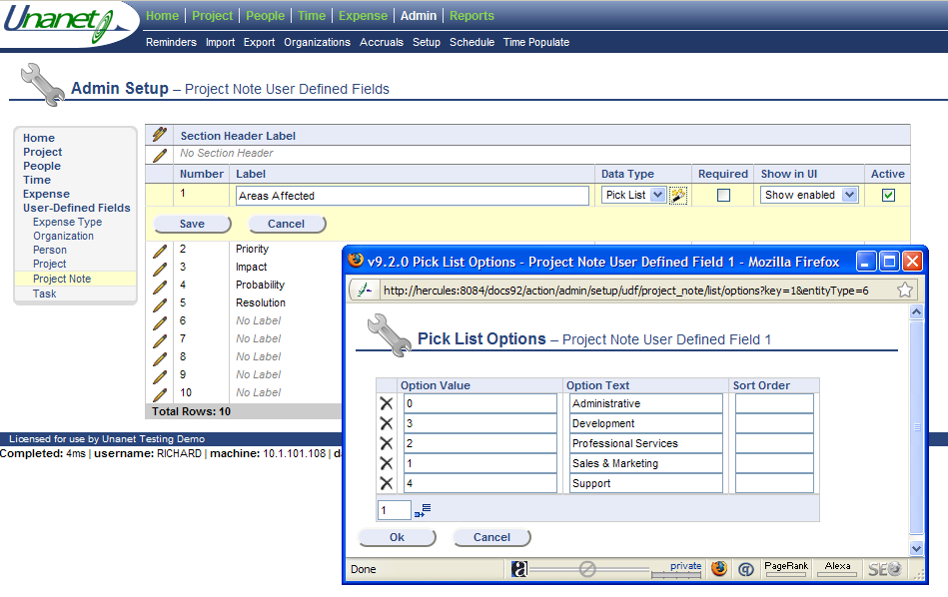

The Notes UDF Priority is also defined as a pick-list. In this example three values for Priority have been defined, High, Medium & Low.

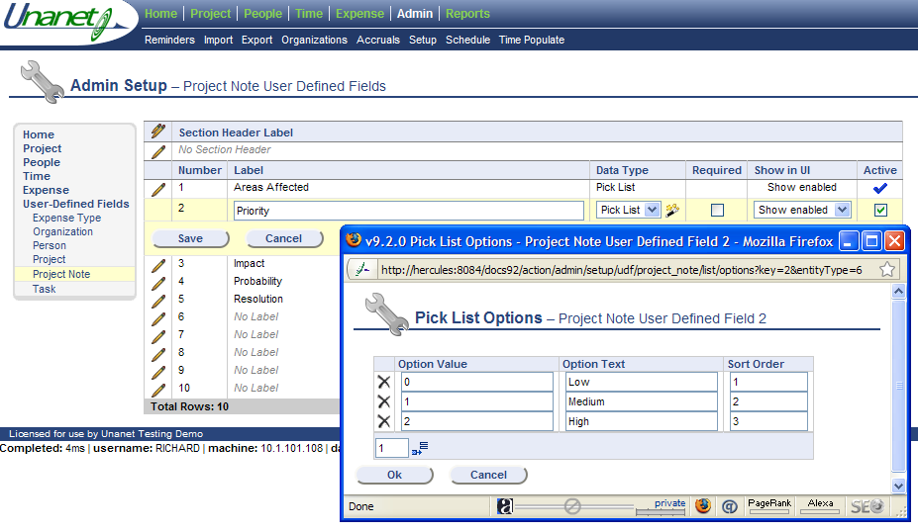

Impact is a common attribute of Risks or Issues. In this example there are five classifications of Impact: Unimportant, Low, Moderate, Severe, and Catastrophic.

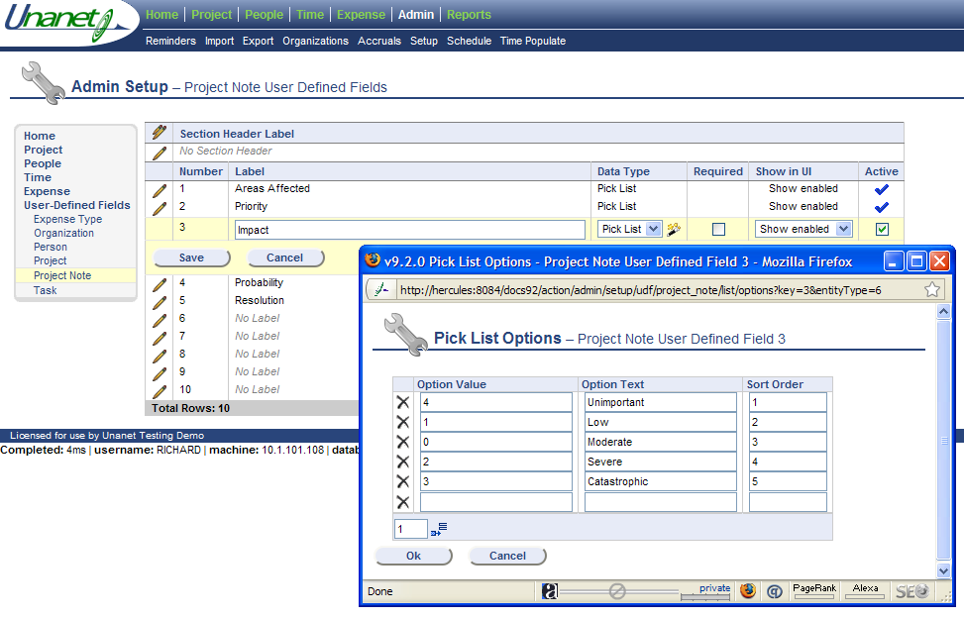

Risks usually have a Probability assigned to them. In the example here the pick-list includes five values representing different ranges of likelihood. Note: a Risk with 100% probability should be classified as an Issue!

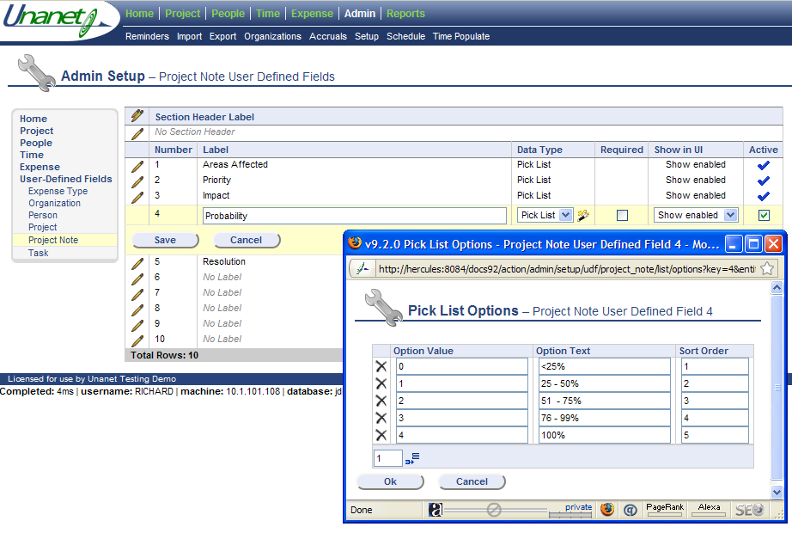

Other Notes User Defined Fields can be created up to a total of ten items. The final example included here is Resolution. This is defined as a text field data type and could include a description of the action to be taken to resolve or mitigate the risk or issue.

Create Project Note:
When a new Project Note is created a number of new fields are available:
- Note Title
- Note Status
- Due Date (Replaces Action Date)
- Completed Date
- Assignee
- The various Notes UDFs defined by an Admin are also presented.
Each Note also now has a unique number identifier, allocated sequentially when the Note is created.
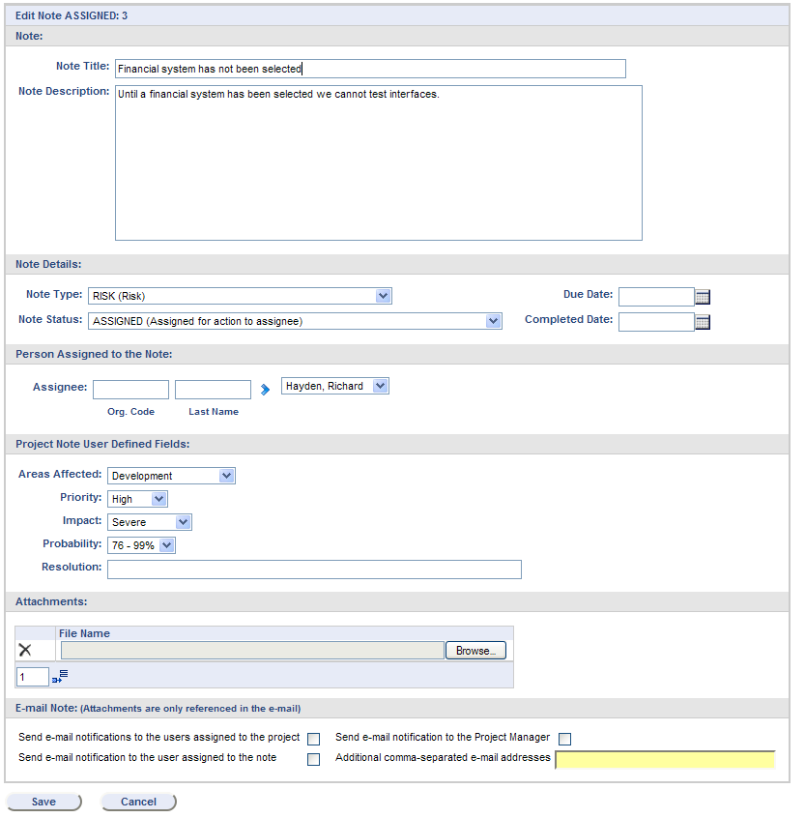

In Unanet 9.5, the ability to restrict Note Access by Role was introduced. A new check box, when selected, displays all roles. By default all roles have access to a Note. If there was specific information to which access needed to be restricted, this can now be accomplished at the individual Note level.

The Notes Search Page has additional options with new fields for:

- Assignee
- Note ID
- Note Status
- Completed Date
- Title Contains (search box)
- List Options – allows UDFs, Note Description and Comments to be shown
- # of Notes to Display (similar to prior Last Entries option)

An Audit Trail is now available for each Note in the Project Note List via the eyeglasses icon. This allows significant changes to the content of a Note to be tracked. The audited fields are:

- Modified Date
- Modifier
- Note Type
- Note Status
- Assignee
- Due Date
- Completed Date
- And all the Note User Defined Fields

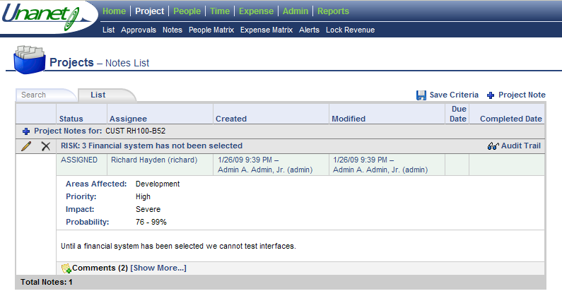

Once a Note has been created, Comments can be added by the original author and other users. This is available by clicking on the icon at the foot of the particular Note you want to add a Comment for.
Existing Comments can be edited or deleted using the appropriate icon .

Also available is a Save Criteria option on the right or the Search page or the Notes List. This operates similarly to a Saved Report and allows you to save multiple search criteria for Notes on any of your Dashboards. These Saved Searches appear in the My Lists area on each Dashboard under the My Reports section.

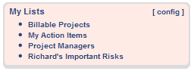

In the example above, two Saved Criteria for Note Types have been added to the My Lists area of this Dashboard. My Action Items includes Note Types classified as Action Items where the user is a creator or assignee. The Risk list includes those Notes classified as Risks, which are of Medium or High Priority.

The new My Lists feature provides ‘one-click’ access to Project Notes, People and Projects lists according to the criteria you save. Data is editable directly from the List without the need to navigate from a report to this data presented.

Comments can now be added to Project Notes as shown in the example below:

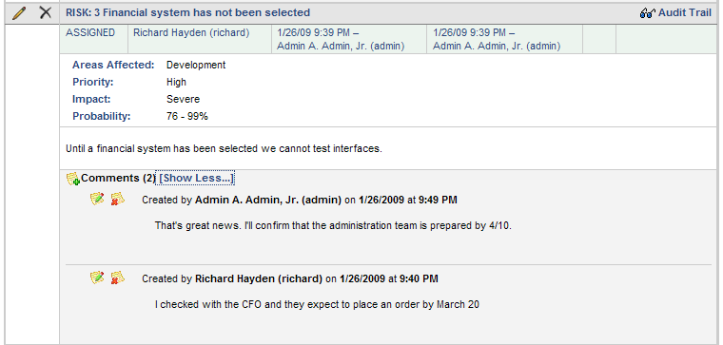

This area is expandable and collapsible to show/hide detail.

Project Status Report
To further aid the new project management and collaboration enhancements available via Project Notes, selected Notes can now be included on the Project Status Report. The Project Status Report selection criteria now has a check box to ‘Show Project Notes’.

Checking this box presents an additional set of criteria appear exactly as on a Project Notes Search screen. This allows you to run a Project Status Report and include information on relevant risks, action items, issues or other items associated with the project. As with other reports, these criteria can be saved and run from a Dashboard. Again note that on the Search Criteria you have access to the User Defined Fields you created to select exactly the data you want.

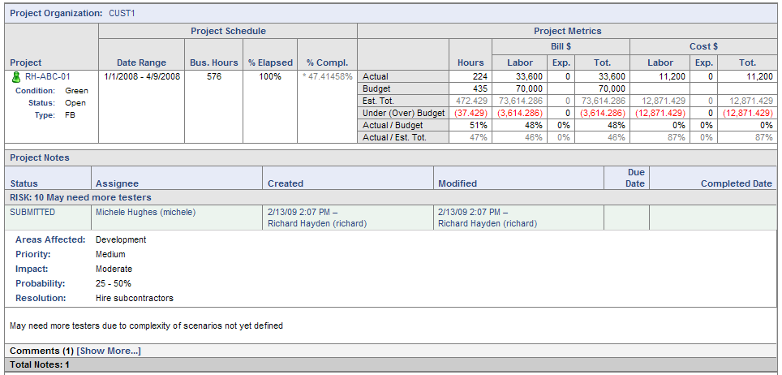

In the example above, a single Note meets the selection criteria for the report. Comments associated with the note can be expanded or collapsed directly from the report.

Useful Additional Information on Risk Management Processes:
Capability Maturity Model Integrated Guide description of the Risk Management Process Area. (See Pages 420 – 439)
http://www.sei.cmu.edu/cmmi/models/model-v12-components-word.html

